ADTA 5940: Arrival Time Change Prediction in Airline Operations
Module 2: Exploratory Data Analysis
Business Context
To run an airline efficiently, it is important to accurately predict arrival times so that airlines can make timely connecting flight decisions. Airlines have a limited timeframe of 30-55 minutes after departure to determine whether to hold for a connecting aircraft or not. Flight delays and other operational variations cause an arrival estimate after the flight has departed. The purpose of this exploratory analysis is to examine how close the estimated arrival time can be estimated after the flight has left a scheduled terminal, to see what possible indicators are available from closed flights.
Visualization 1: Distribution of Arrival Time Variance
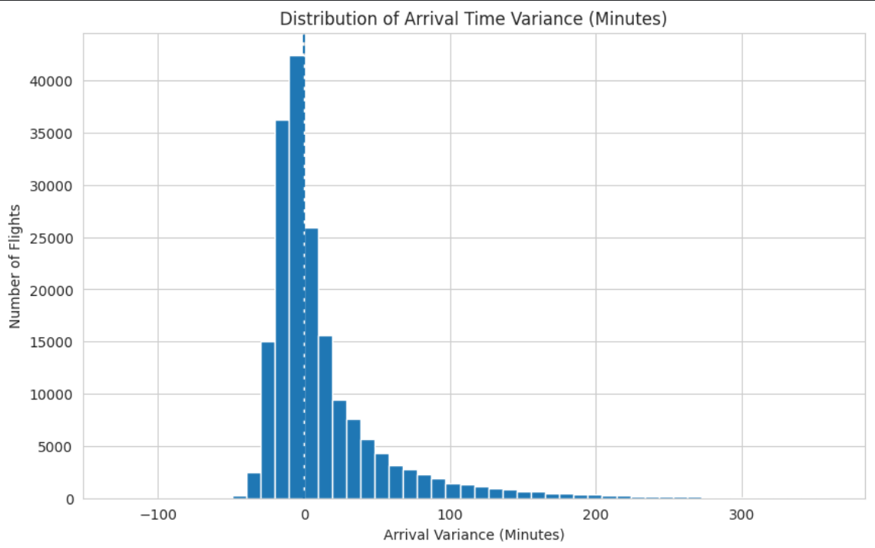
Flight arrival variability indicates that the majority of flights land very closely to the scheduled times (with a median landing time of -2 minutes), indicating that most flights arrive "early". However, the distribution of flight landing times is distinctively right-skewed and contains a disproportionately large number of flights that have incurred substantial delays and have long-duration flight delays.
Flight delays exhibit a notable degree of variability compared to on-time flights (which generally arrive exhibiting very little variability); therefore, there are a limited number of flights with significant numbers of delayed arrival times, thus introducing instability in the majority of the operational issues.
Given the increased likelihood that more flights will incur delays; it would be reasonable to suggest that these delays will be more accurately predicted; thus providing insight and valuable operational analysis regarding the likelihood of flight delays.
Visualization 2: Departure vs. Arrival Variance
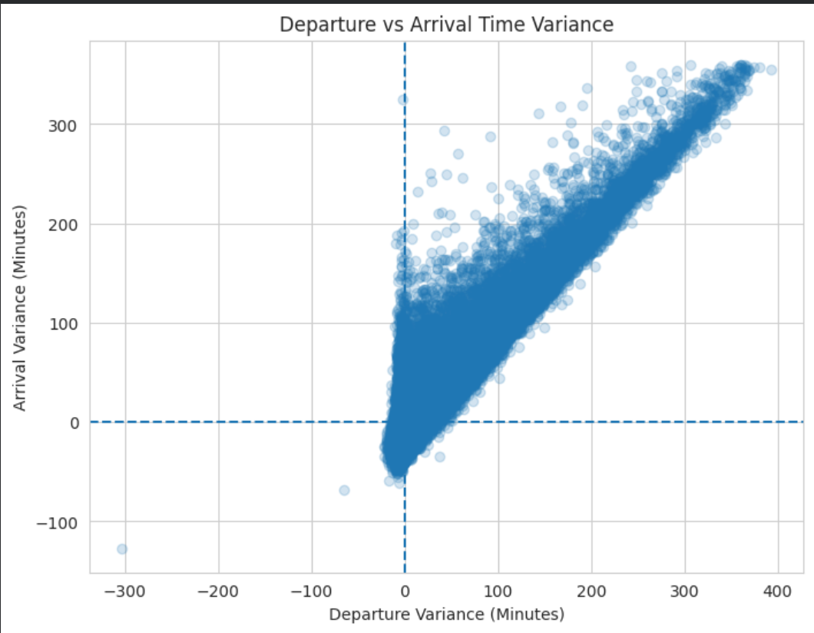
The relationship between the variability of departure timings and the variability of arrival timings demonstrates that flights will have longer arrival times than scheduled when they depart late. Therefore, the magnitude of the delay at arrival may be in proportion to the magnitude of the delay at departure.
For instance, small, late departures can be adjusted through planning during the course of the trip, while large, late departures can create variability in the arrival times themselves. Accordingly, the combined variances of both the departure and arrival can be used to produce a numerical value that represents the performance of an aircraft at the time of takeoff, which can serve as an indicator of how the arrival times will be affected after the aircraft leaves the departure airport.
Data Understanding and Analytical Decisions
The original dataset had over two hundred twenty-nine thousand total records of flights with multiple updates to each flight's record; however, only final records where kept to analyze actual arrivals as opposed to updated flights. Records in the dataset that were outside the limits of realistic operation were also removed in order to correct for the bias created through outlier records from the results of skewing the distribution.
Variance of arrival times was used as the primary performance measure to evaluate arrival performance (variance). Variance is determined by taking the difference in time between the scheduled and actual time that each flight arrived (in minutes). The organization of the distribution and the clear pattern of delay propagation suggests that arrival times are not random; but are influenced by operating conditions, specifically how well each flight departed.
Implications for Next Phase
The exploratory analysis confirms that variations in aircraft arrival times have an identifiable pattern, as well as an operational relationship. The second phase will involve creating predictive models to:
(1) Classify flights that will experience substantial deviations from their estimated arrival time after takeoff.
(2) Estimate the magnitude of deviation in minutes.
Acknowledgment:
ChatGPT was utilized as a writing support tool to improve grammar, sentence structure, and document clarity. The research design, data analysis, insights, and interpretations are entirely the original work of the group members.

